StirMark Benchmark 4
Contact names | Caroline Fontaine, Sciences et Technologies de Lille, caroline.fontaine@lifl.fr  Fabien A. P. Petitcolas, Microsoft Research, fabienpe@microsoft.com  Frédéric Raynal, INRIA, frederic.raynal@inria.fr  Jana Dittmann, G.M.D.-IPSI, (dittmann@darmstadt.gmd.de)  Martin Steinebach, G.M.D.-IPSI, (martin.steinebach@darmstadt.gmd.de)  Nazim Fatès
Status | Draft
Based on | Frédéric Raynal, ‘Benchmark’, working draft, 15 Feb. 2000-04-25  Matthieu Brunet, ‘Évaluation de schémas de tatouage d’images’, meeting report, 7 Mar. 2000
Scope | Restricted
Created | 2000-04-20 10:13
Last Updated | 2002-04-19 11:15
Version | 49

Contents
Contents 1
Introduction 1
Goal of the project 1
Design goals 2
Architecture 2
Client-server interaction 2
Test platform architecture 3
User A.P.I. 3
Image database 6
Evaluation criteria 6
Attacks on the signal 7
Multiple marks 7
False positives 7
Interpretation of the results 7
Programming language 7
Definitions 7
Classes 8

Introduction
There are two major problems to the evaluation and comparison of currently proposed watermarking schemes:
- Most presented results are based on a very limited set of samples. This prevents potential users from having an overview of the general performances of the scheme.
- The number of possible applications to digital watermarking leads to different needs hence evaluation criteria.
This justifies the urgent need for an independent, fair and reliable evaluation method based on rigorous experimental procedures. A first attempt was described in [] but here again the tests were fairly limited and did not really take into account the application for which the watermarking algorithm was designed.

Goal of the project
StirMark Benchmark Evaluation Service aims at:
- Designing and developing a fully automated and complete benchmark suite for digital watermarking schemes;
- Making this benchmark one of the reference services for researchers, suppliers of watermarking technologies, industrial users and end users.
During the first phase of this project, we will focus on still image watermarking technologies but we will allow possible extensions to audio and video watermarking.
Since watermarking may have many different purposes, watermarking schemes ought to be sorted according to their principal target use before any benchmark and comparison can be done. It also seems natural to study each of the main parameters involved in watermarking – namely, visual quality after marking, bit-error (robustness) and the strength of the attack – using different graphs (e.g., robustness vs. attack, attack vs. visual quality, etc.). However this is not always possible and the analysis may be biased if not done carefully.
Given an implementation of a watermarking scheme, the StirMark Benchmark Evaluation Service will test is thoroughly, collect test results and analyse these results in order to produce fair and useful evaluation.
- The first step is to clearly identify the target of evaluation (T.O.E.), that is the watermarking scheme subject to evaluation in particular the type of watermarking algorithm, from which the security target can be derived.
- One needs also to select an evaluation profile that is a set of requirements and specifications to be used as the basis for evaluation. This clearly depends on the T.O.E. In the case of a watermarking algorithm optimised for proof of ownernership of natural photographs, one will have to verify, for instance, that it is not possible to fake the identity of the owner of the photograph. In the case of a watermarking algorithm optimised for tamper detection of road maps, however, the evaluation must show that it is not possible to modify the road map without triggering the algorithm in some way.
- Once these are well defined, one can select the set of evaluation criteria that is the tests which will actually be applied to the scheme to check it achieves the security objectives to a certain degree of assurance. Hopefully – this is not necessary the case though – the more assurance the better the scheme, according to the agreed criteria. This implies a choice of a set of images on which the test will be done. Set of requirements that could serve as basis to some evaluation profiles have been published in some calls for proposals [][].

Design goals
- Simple interface with watermarking libraries (see Error: Reference source not found section).
- Modularity
  - It should be possible to add new evaluation profiles without having to recompile the code. These profiles could be described in text configuration files.
  - It should be possible to add new tests and attacks easily. When this is done the evaluation service should test all the libraries it has received using these new tests, provided they are listed in the evaluation profile associated to the marking scheme.
  - The same applies to new images.
- Allow the client to decide whether the results will be publicly available or not. If not the evaluation should be done as a low priority job.
- Possibility to detect cheating (e.g., very high false positive rate).
- All evaluation procedures, profiles and code publicly available.
- Possibility to download the benchmarking software.
- Allow client to submit libraries for different platforms (at least Windows and Linux).
- Option to cryptographically sign results.

Architecture

Client-server interaction
Users of the StirMark Benchmark Evaluation Service will be required to provide and A.P.I. for the watermarking scheme they wish to have evaluated. This A.P.I. will contain to main entries: one for watermark embedding and the other one for watermark detection and payload extraction.
Users will send their software as a compiled library or executable (for Windows or Linux) to the StirMark Benchmark Evaluation Service web server. This library will then be copied on a P.C. where the evaluation will be carried out.
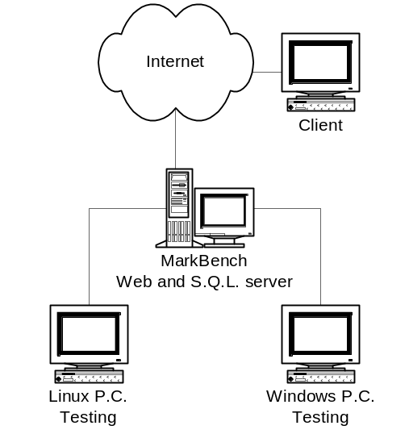
- The client (watermarking scheme provider) connects to the StirMark Benchmark Evaluation Service server, fills a form and send its library;
- The server analyses the form and copy the library on the relevant testing P.C.;
- The P.C. runs the tests and save the results in a file;
- If no cheating has been detected (we must have tests to detect obvious cheating) the results are sent to the S.Q.L. server;
- When the database is updated, en email is sent to the contact address;
How do we prevent people from submitting someone else’s watermarking libraries?

Test platform architecture
In order to ensure modularity the amount of features coded in the main benchmark tool should be minimal. One possible solution is to rely on the use of file system directories:
/ | Bin/ |  | Benchmark/ |  | the benchmarking tool itself
 |  |  | Libraries/ |  | libraries sent by users
 | Profiles/ |  |  |  | profiles are text configuration files describing the test to be applied (one profile per application and per 'robustness' level)
 | Media/ | Input/ | Images/ | MyFolder1/ | samples sorted according to some criteria
 |  |  |  | MyFolder2/
 |  |  |  | …
 |  |  | Sounds/ | MyFolder1/
 |  |  |  | MyFolder2/
 |  |  |  | …
 |  | Output/ |  |  | Same substructure is created for input.

User A.P.I.
The A.P.I. provided by the will contain the three following entries:
- The GetSchemeInfo function will enable the testing P.C. to get information about the watermarking scheme: authors, version, type of scheme, etc.
- The Embed function will be called by the testing P.C. to watermark an input signal;
- The Extract function will be used by the testing P.C. to detect a watermark or extract a payload;
They are defined in the StirMarkBenchmark.h header file:

/*----------------------------------------------------------------------------
// StirMark Benchmark - StirMarkBenchmark.h
//
// Contents: The main header file of the StirMark Benchmark project
//
// Purpose: This header file will be exported to watermarking providers.
// It basically defines the interface between the StirMark server
// and the marking scheme libraries.
//
// Watermarking providers need only present 3 functions. Their
// prototype is at the end of this header file:
// - GetSchemeInfo
// - Embed_Image_Lib
// - Extract_Image_Lib
//
// Support for other media will be added in the near future.
//
//
// Created: Fabien A. P. Petitcolas, Microsoft Research
// Frédéric Raynal, INRIA
// Matthieu Brunet, INRIA, 7 March 2000
//
// Modified: Nazim Fatès, Microsoft Research
//
// History: 7 March 2000 - Created after meeting at INRIA Rocquencourt.
// The general functional interface was defined.
//
// $Copyright$
//
// $Header: /StirMark Benchmark/Base/StirMarkBenchmark.h 32 20/03/02 15:17 Fabienpe $
//----------------------------------------------------------------------------
*/

#if !defined(_STIRMARKBENCHMARK_H_)
#define _STIRMARKBENCHMARK_H_

#if !defined(WIN32)
#if !defined(__UNIX__)
#define __UNIX__
#endif
#endif

#if _MSC_VER > 1000
#pragma once
#endif /* _MSC_VER > 1000 */

/* Return code for Embed and Extract procedures */
#define SMBFAILURE (-1)
#define SMBSUCCESS (0) /* this code only means that */
/* the operation went through */
#define SMBERROR_KEY_TOO_LARGE (1L)
#define SMBERROR_UNSUPPORTED_KEY (2L)
#define SMBERROR_MSG_TOO_LARGE (3L)
#define SMBERROR_UNSUPPORTED_MSG (4L)
#define SMBERROR_BAD_FORMAT_IMAGE (5L)
#define SMBERROR_UNSUPPORTED_IMAGE_SIZE (6L)
#define SMBERROR_UNSUPPORTED_STRENGTH (7L)
#define SMBERROR_NOT_ENOUGH_MEMORY (8L)
#define SMBERROR_UNEXPECTED_PARAMETER (9L)
#define SMBERROR_MORE_DATA_AVAILABLE (10L)
#define SMBERROR_UNSUPPORTED_SCHEME_FAMILY (11L)

/* Basic type definitions */
typedef long ErrorNum; /* See beginning of this file */
typedef char * STR; /* Character string */
typedef const char * CSTR; /* Constant character string */
typedef unsigned char Gray; /* Grayscale value of a pixel in colour plane */

/*----------------------------------------------------------------------------
// Image support
*/

/* Coding types for pixels in an image */
enum ImageType {
IT_GRAY, /* 1 channel - grayscale image */
IT_RGB /* 3 channels - standard RGB colour image */
};

/* Many image processing functions need intensity values for pixels
// that lie outside the image. The following options can be used
// to specify how border pixels are handled.
*/
enum BorderMode {
BM_CONSTANT, /* A constant value is used for the border */
BM_REPLICATION, /* The last row or column is replicated for the border */
BM_REFLECTION, /* The last row or column is reflected in reverse order */
BM_WARPING /* The row or column of the opposite side is used */
};

/* Image information structure */
typedef struct {
ImageType itType;
unsigned int nChannels; /* Number of colour channels, e.g. 1 for IT_GRAY */
Gray gMaxVal; /* Maximum pixel component value */
long lCols; /* Number of columns (width) */
long lRows; /* Number of rows (height) */
BorderMode bmMode; /* Border handling mode */
Gray gBrdValue; /* Constant value used for border if BM_CONSTANT */
Gray *pgData; /* Pointer to the grayscale value of all pixels */
/* from top left pixel to bottom right pixel. */
/* For RGB images it is assumed that values are */
/* given in the following order: R, G then B. */
} SMBImage;

static SMBImage SMB_NULL_IMAGE = {IT_GRAY, 0, 0, 0, 0, BM_CONSTANT, 0, 0};

/*----------------------------------------------------------------------------
// Sound support
*/

/* Sound information structure */
typedef struct {
unsigned int nChannels; /* number of channels */
unsigned long nSamples; /* number of samples */
unsigned int nSamplesPerSecond;
unsigned int nBitsPerSample;
} SMBAudioInfo;

/*----------------------------------------------------------------------------
// Families of watermarking schemes
*/
#define SF_PRIVATE_1 (1) /* Non-blind type I */
#define SF_PRIVATE_2 (2) /* Non-blind type II */
#define SF_BLIND_1 (5) /* Blind type I */
#define SF_BLIND_2 (6) /* Blind type II */
/* #define SF_SEMIBLIND_1 (3) */ /* Semi-blind type I */
/* #define SF_SEMIBLIND_2 (4) */ /* Semi-blind type II */

/*
// - Type I scheme: the output of the extractor is either the payload or
// a symbol meaning the absence of mark in the signal to be tested;
// - Type II scheme: such schemes require knowledge of the embedded
// watermark for detection in a signal. Such schemes are only able to
// tell whether a given watermark is present or not;
// - Non-blind (private) scheme: the original non-watermarked
// audio-visual signal, the watermarking key and the signal to be
// tested are required for the detection;
// - Semi-blind scheme: the published watermarked audio-visual signal,
// the watermarking key and the signal to be tested are required for
// the detection;
// - Blind (public) scheme: only the watermarking-key and the signal to
// be tested are required for the detection;

/* Evaluation profile
//
// Evaluation profiles depends on the application.
// One can think of them as set of requirements.
*/
enum EvaluationProfile {
/* TODO: we are working on this */
};

/* Assurance level
//
// This describes how thouroughly the evaluation is done
// how well the requirement are followed
*/
enum AssuranceLevel {
/* TODO: we are working on this */
};

/*----------------------------------------------------------------------------
// Watermarking scheme parameters for embedding or extraction function
*/

typedef struct {
STR inout_pMsg; /* Message extracted OR to embed */
STR in_pKey; /* Key for extraction OR for Embedding */
double in_dpStrength; /* Strength for embedding/extraction */
double out_dpCertainty; /* Certainty of extraction */
double in_dpPSNR; /* Minimal wished PSNR of output */
} SMBSchemePars;

/* pKey is always provided by the calling function. It is a pointer to a
// block of memory containing the watermarking key. The size of this
// block is the one provided by GetSchemeInfo_Lib when using the
// MS_KEYMAXSIZE selector.
//
// pMsg should always be allocated by the calling function. For embedding
// it should be set to the message one wishes to embed. For extraction it
// will be set by the caller either to 0 or to the message that is
// expected to be extracted. This depends on the family of the
// watermarking algorithm. The size of this block is the one provided by
// GetSchemeInfo_Lib when using the MS_MSGMAXSIZE selector.
//
// The dpStrength parameter is used to specify the embedding strength and
// is assumed to have the following properties:
// - dpStrength is a double precision number between 0 and 100;
// - the higher the value of dpStrength, the lower the quality of the
// output image and the higher (hopefully) the 'robustness';
// - dpStrength = 0 corresponds to no watermarking (P.S.N.R. -> infinity);
// - dpStrength = 100 should correspond to a watermarked picture with
// P.S.N.R. around 20 dB;
// - the distribution dpStrength should be 'harmonious'.
// - if dpStrength is set to -1 dpPSNR is used to adjust the strength of
// the emebedding
//
// dCertainty is used for extraction only. It's the probability (double
// precision number between 0 and 100) that the extracted information is
// correct. Mainly used by Type II schemes.
//
// dpPSNR is used for embedding when dpStrength is set to -1. dpPSNR is
// specified by the caller. It takes a PSNR value in dB and indicates to
// the embedder that it should use the best strength such that the PSNR
// of the output image is greater or equal to dpPSNR.

/*----------------------------------------------------------------------------
// Headers of the functions exported by the library under test
*/
#ifdef __cplusplus
extern "C" {
#endif /* __cplusplus */

/*----------------------------------------------------------------------------
// Information about the watermarking scheme implemented in the library
*/
#ifdef DLLEXPORT
DLLEXPORT
#endif /* DLLEXPORT */
ErrorNum GetSchemeInfo_Lib(int in_nInfo,
unsigned char *out_pbData,
unsigned int *inout_pcbData);

/* in_nInfo governs the nature of the query: */
#define MS_NAME (1) /* Name of the marking scheme */
#define MS_VERSION (2) /* Version of the scheme */
#define MS_AUTHOR (3) /* Author(s), research group or company */
#define MS_RELEASEDATE (4) /* Release date of the current version */
#define MS_DESCRIPTION (5) /* Notes and comments regarding the scheme */
#define MS_SOURCELOCATION (6) /* URL of the sources */
#define MS_CONTACTADDRESS (7) /* Email of the contact */
#define MS_MSGMAXSIZE (8) /* Maximum byte-length of the embedded message*/
#define MS_KEYMAXSIZE (9) /* Maximum byte-length of the stego-key */
#define MS_SCHEMEFAMILY (10) /* Family of the watermarking scheme */

/* pbData is a pointer to the location where the data will be returned,
// and pcbData is the size, in bytes, of the returned data. If the buffer
// specified by pbData parameter is not large enough to hold the returned
// data, the function returns SMBERROR_MORE_DATA_AVAILABLE, and stores the
// required buffer size, in byte, into the variable pointed to by pcbData.
// If NULL is input for pbData and pcbData is non-NULL, no error is
// returned and the function returns the size of the needed memory buffer,
// in bytes, in the variable pointed to by pcbData.
// This lets the caller determine the size of, and the best way to
// allocate, a buffer for the returned data.
//
// Return value: SMBSUCCESS, SMBERROR_MORE_DATA_AVAILABLE or
// SMBERROR_UNEXPECTED_PARAMETER
*/

/*----------------------------------------------------------------------------
// Embedding and extraction functions
//
// In our implementation we assumed that the module which allocates memory
// also releases the memory. Consequently out_pimgTarget is a pointer to
// an SMBImage structure which has already been initialised. In particular
// the pgData blob has been allocated but contains random data (not
// necessarily a copy of the original image). in_imgOriginal and out_pimgTarget
// images are assumed to have the same size. However the in_imgTest image
// may have a different size. Embedding will be done with payload and keys
// of maximal length (the ones provided by GetSchemeInfo_Lib).
*/

#ifdef DLLEXPORT
DLLEXPORT
#endif /* DLLEXPORT */
ErrorNum Embed_Image_Lib(
const SMBImage in_imgOriginal, /* Original image */
SMBImage * out_pimgTarget, /* Image to mark */

const SMBSchemePars * in_pPars /* Pars for embedding */
);

#ifdef DLLEXPORT
DLLEXPORT
#endif /* DLLEXPORT */
ErrorNum Extract_Image_Lib(
const SMBImage in_imgTest, /* Marked/attacked image */
const SMBImage in_imgOriginal, /* Marked/unmarked image */
/* OR SMB_NULL_IMAGE */
SMBSchemePars * inout_pPars /* Pars for extraction & output */
);

#ifdef __cplusplus
}
#endif /* __cplusplus */

#endif /* !defined(_STIRMARKBENCHMARK_H_) */

Image database
- Identify different images families;
- Setup an image database.

Evaluation criteria

Attacks on the signal
Can use ideas and code from the StirMark benchmark.
Note that one of the ‘attacks’ is the identity function.

Multiple marks

False positives
There are two types of false positives:
- The detector/extractor find a mark in an image without mark;
- The detector/extractor find a mark w’ on an image marked with w.
What’s the penalty for each type of error?
Can’t we use importance sampling ‘theory’?

Interpretation of the results
One of the main problem which remains after applying these attacks is how to extract some meaningful conclusions from the results.
The attacks will be applied with various levels of strength in order to have a range as wide as possible. More over it is very likely that several attacks will be combined.
Notice that many attacks use random parameters; actually the watermarking itself uses some kind of random information. Consequently one should never expect a deterministic solution to our evaluation problem. The main factors which characterise an attack that we identified are: the marked image, the strength of the embedding, the kind of attack, its intensity and the random factors.
The presentation of the results should not hide the possible specificity of a given scheme so the output will probably be a fairly long data sheet. This should not prevent having some summary and graphs though.
The evaluation will provide some performances measures related to the imperceptibility, specific goals, and robustness of a given scheme. It will also measure the ‘speed’ of the algorithm based on a particular platform. This is important for commercial products but less meaningful for academic prototypes.

Programming language
C++ with standard libraries.

Definitions
- Watermark: what is actually imperceptibly added to the cover-object in order to convey hidden data.
- Payload: message to be hidden in an object, that is the hidden data.
- Watermark-access-unit (W.A.U.): smallest part of an audio-visual signal in which a watermark can be reliably detected and the payload extracted;
- Capacity: bit size of a payload that a W.A.U. can carry;
- Watermarking scheme: the set algorithms required for embedding and extraction;
- Watermarking key: a secret used to embed the mark. Knowledge of this secret is required to detect the mark. Knowledge of this secret may also allow a malicious attacker to remove the mark;
- Non-blind (private) scheme: the original non-watermarked audio-visual signal, the watermarking key and the signal to be tested are required for the detection;
- Semi-blind scheme: the published watermarked audio-visual signal, the watermarking key and the signal to be tested are required for the detection;
- Blind (public) scheme: only the watermarking-key and the signal to be tested are required for the detection;
- Type I scheme: the output of the extractor is either the payload or a symbol meaning the absence of mark in the signal to be tested;
- Type II scheme: such schemes require knowledge of the embedded watermark for detection in a signal. Such schemes are only able to tell whether a given watermark is present or not;

Classes
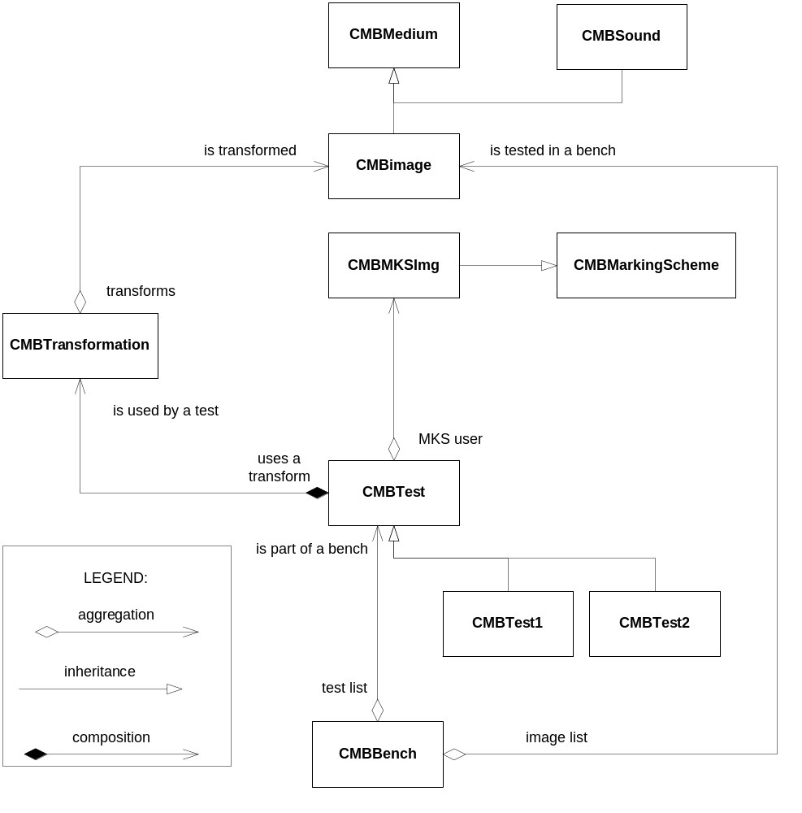
CSMBMedium – This is the base class from which the class CSMBImage is derived. Next versions may have CSMBSound and CSMBVideo derived from it. This class is also responsible for memory. In order to simplify error handling it’s probably better not to do any allocation in the constructor and hence to ban copy constructors. A CopyFrom and Initialise functions may be provided instead. Although it breaks the OO model, access to the bulk of data is important (especially for passing the information to the embedder or the extractor) so a GetData function may also be provided.
CSMBBench – CSMBBench is a general wrapper class for all possible benchmark. It uses a list of tests and a list of images. These lists depend on the evaluation profile being used.
CSMBTest – This class takes an image (or a list of images) and a marking scheme as an input and performs a test on it. The test can be whatever we need. Typical tests are false-alarm tests (use of importance sampling?) and robustness tests (embedding, transformation, extraction).
CSMBMarkingScheme – This is the base class for marking schemes. It acts as an interface between the StirMark Benchmark object model and the libraries provided by the users. Subclasses depend on the medium used.
CSMBImageTransform – This class performs a transformation on a medium. This includes filtering, geometric transformation and any other distortion required for testing.

Martin Kutter and Fabien A. P. Petitcolas. A fair benchmark for image watermarking systems. In Ping Wah Wong and Edward J. Delp, editors, proceedings of Electronic Imaging '99, Security and Watermarking of Multimedia Contents, vol. 3657, pp. 226--239, San Jose, California, U.S.A., 25--27 January 1999. The Society for Imaging Science and Technology (IS&T) and the International Society for Optical Engineering (SPIE). ISSN 0277-786X. ISBN 0-8194-3128-1.
Message from Louis Cheveau to the ‘watermark@nsc1.ee.nctu.edu.tw’mailling list. Subject: EBU extended ‘Video Watermark Call for Sytems’. 12 May 2000.
Secure Digital Music Initiative, Call for proposals for phase II screening technologies, version 1.0, 24 February 2000. <http://www.sdmi.org/public_doc/FRWG00022401-Phase%202_CFPv1.0.PDF>

